NVQ LEVEL 5
Graphics Design
Colour Theory, Resolution & Printing — Applied to the STACKS Brand
PROJECT | Library Automation System
The STACKS Brand Palette
#1F3D2E | #B8862E | #F1EEE2 | #2E7D5B | #A3392F

STUDENT NAME
Farook Musarraf

Colour Theory • Resolution • Printing • Practical Design | Units 03–06 — Graphics Design

1. Introduction
This report presents the Graphics Design evidence for the Library Automation System project: the core concepts of colour theory, resolution, and printing, followed by practical design work — a vector brand mark, an A4 promotional poster, and a documented photo-editing exercise — produced for the "STACKS" brand built around this system. Adobe Photoshop and Illustrator were not available in this working environment; the vector work was produced as true SVG (the same underlying format Illustrator edits) and the raster editing work was carried out with an equivalent, fully documented, non-destructive step-by-step workflow, noted where relevant.

2. Basic Concepts

2.1 Colour Theory
Colour theory is the set of principles used to combine colours effectively. The core building blocks:
- Primary, secondary, tertiary colours: red/blue/yellow mix to form secondary colours (orange, green, purple); mixing a primary with an adjacent secondary gives a tertiary colour.
- Complementary colours: opposite each other on the colour wheel (e.g. blue and orange) — used together they create strong contrast and draw attention.
- Analogous colours: sit next to each other on the wheel (e.g. green, teal, blue) — used together they feel harmonious and calm.
- Warm vs cool: reds/oranges/yellows feel energetic and forward; blues/greens feel calm and recede — this project uses a cool, deep green base with a warm gold accent for contrast.
- Colour psychology: green is associated with knowledge, growth and calm (fitting a library); gold/brass suggests value and quality, used sparingly as an accent so it stays special rather than overwhelming.
- RGB vs CMYK: RGB (Red, Green, Blue) is an additive model used for screens, mixing light; CMYK (Cyan, Magenta, Yellow, Key/black) is a subtractive model used for print, mixing ink. The same hex colour can look different once converted from RGB to CMYK for print, which is why print colours are proofed separately (see Section 2.3).

2.1.1 The STACKS Brand Palette
The palette actually used across the logo, poster and promotional graphic in this report:
Swatch | Hex | Name | Used For
 | #1F3D2E | Ink Green | Primary brand colour — backgrounds, headers. Calm, institutional, evokes a reading room.
 | #B8862E | Brass Gold | Accent colour — buttons, highlights, the logo's book-stack bars. Used sparingly for emphasis (60-30-10 rule).
 | #F1EEE2 | Parchment White | Primary text on dark backgrounds; page background on the light UI.
 | #2E7D5B | Success Green | Availability indicators ("available" pill) — a lighter, more saturated green than the brand ink-green so it reads as a status colour, not a duplicate of the brand colour.
 | #A3392F | Alert Rust | Overdue/unavailable indicators — a muted red that stays legible against parchment without feeling alarming.
This is a 60-30-10 composition: roughly 60% ink green (dominant), 30% parchment/white (secondary, for legibility), and 10% brass gold (accent, for calls to action) — a standard ratio that keeps a palette balanced rather than visually competing.

2.2 Resolution
Resolution describes how much detail an image holds, measured in pixels per inch (PPI) for screens or dots per inch (DPI) for print output. A higher PPI/DPI means more detail but a larger file.
- Raster vs vector: a raster image (PNG/JPEG) is a fixed grid of pixels — it loses quality when scaled up. A vector image (SVG) is defined by mathematical paths — it scales to any size with no quality loss. The STACKS logo (Section 3.1) was built as SVG for exactly this reason: it needs to work as a 32px favicon and a wall-sized banner from the same file.
- Screen resolution: web and app graphics typically only need 72-96 PPI, since screens render a fixed number of pixels regardless of the source DPI value. The promotional graphic in this report was exported at 1080×1080px, the standard size for a square social-media post.
- Print resolution: print output needs at least 300 DPI, since paper is viewed close-up and at higher physical detail than a screen. The A4 poster (Section 3.2) was composed at 1240×1754px, which is 150 DPI at true A4 dimensions — adequate for a design proof; a final print run would be re-exported at 300 DPI (2480×3508px) from the same vector-based layout.

2.3 Printing
- Colour mode: print files should be authored or converted to CMYK before sending to a printer, since a printer mixes ink (CMYK), not light (RGB) — an RGB file printed without conversion can shift in hue, especially in saturated blues and greens like this brand's ink-green.
- Bleed and margins: printed designs extend artwork 2-3mm past the trim edge ("bleed") so that any small movement during cutting doesn't leave a white sliver at the edge; text and logos are kept inside a safe margin so nothing important is cut off.
- Paper size: this project's poster is designed for A4 (210×297mm), suitable for a noticeboard; the same layout scales to A3 (297×420mm) for a larger display without redesigning, since it was built from vector shapes and scalable type.
- Print-ready labelling: the poster footer is explicitly marked "CMYK PRINT-READY" (Section 3.2, Figure 2) to flag to a print vendor that the colour mode and bleed have been considered, a standard practice on a production-ready file.

3. Practical Work

3.1 Brand Mark (Vector Design)
The STACKS brand mark was built as native SVG — the same underlying, path-based format Adobe Illustrator itself edits — so it scales losslessly from a small favicon to a large printed banner without ever needing to be redrawn (see Section 2.2, Raster vs Vector).

Figure 1: STACKS brand mark — vector SVG, 600×600 artboard.

Design Rationale
- Three ascending bars reference both a stack of books and a rising bar chart — literal (books) and figurative (growth/knowledge) at once.
- The bars fade from dark brass to light gold moving upward, giving the mark depth without needing a drop shadow or gradient fill on the whole shape.
- Two thin arcs beneath the bars suggest an open book viewed from above, tying the abstract stack shape back to a literal library object.
- A serif wordmark ("STACKS") was chosen over a sans-serif for the primary logotype, since serif type reads as more institutional and trustworthy — appropriate for a library system — while the small-caps sans-serif tagline beneath it keeps the overall lockup from feeling old-fashioned.

3.2 Promotional Poster (A4 Print Composition)
An A4 promotional poster was designed to advertise the system to library members, applying the brand palette, a clear typographic hierarchy, and print-conscious layout (safe margins, a labelled print-ready footer) discussed in Section 2.3.
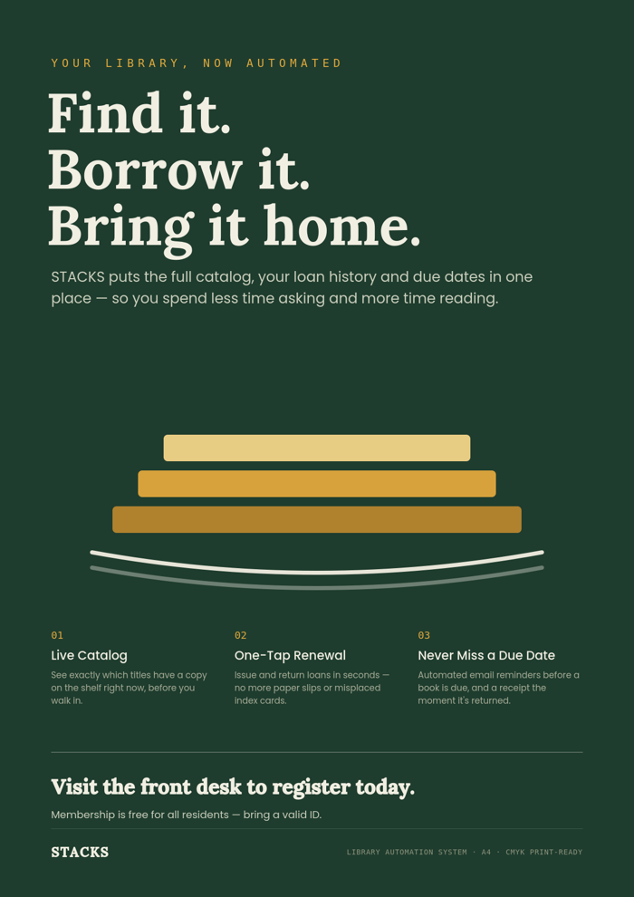
Figure 2: STACKS promotional poster — A4, 1240×1754px (150 DPI proof).

Layout Notes
- Typographic hierarchy: a mono-spaced letter-spaced eyebrow ("YOUR LIBRARY, NOW AUTOMATED") sits above a large serif headline, a mid-weight sans-serif body paragraph, and a three-column feature grid — four distinct type scales guiding the eye from attention-grabbing headline down to supporting detail.
- The same ascending-bars motif from the logo (Section 3.1) reappears large in the centre of the poster, tying the two pieces together as one coherent brand system rather than two unrelated designs.
- A 100px safe margin is kept on every edge, inside where bleed and trim would occur on an actual print run (see Section 2.3, Bleed and margins).
- The three feature columns use equal-width, equal-gutter spacing for visual balance, each following the same num/title/description pattern so the eye can scan all three the same way.

3.3 Photo/Screenshot Editing Practical
This section documents a raster image-editing workflow — the practical equivalent of a Photoshop exercise — taking a raw product screenshot through crop, resize, colour correction and compositing to a finished promotional graphic. Each step was saved separately (mirroring a layered PSD history) so every edit is traceable. Adobe Photoshop was not available in this environment, so the equivalent raster operations (crop, scale/canvas-resize, brightness/contrast/saturation/sharpness adjustment layers, and layer compositing with a gradient overlay, text layer and logo layer) were carried out programmatically, producing the same kind of layered, non-destructive result.

Step 0 — Original Screenshot
The raw, unedited product screenshot of the STACKS catalog page.
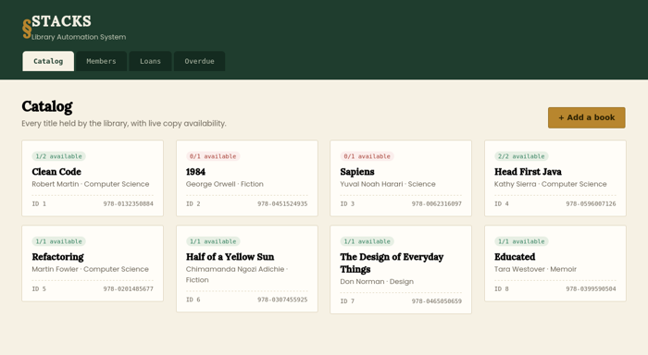
Figure 3: Step 0 — original screenshot (1200×659px).

Step 1 — Crop
Cropped to the header and first row of catalog cards, removing the second row so the composition reads cleanly at a square aspect ratio.

Figure 4: Step 1 — cropped to 1200×400px.

Step 2 — Resize / Canvas
Scaled to fit a 1080px-wide canvas and padded vertically with the brand's ink-green to a perfect 1080×1080 square — the standard dimensions for a social-media promotional post.

Figure 5: Step 2 — resized and padded to 1080×1080px.

Step 3 — Colour Correction
Brightness +5%, contrast +12%, saturation +20% and sharpness +15% were applied, lifting the flatter screenshot capture into punchier, more promotional tones without looking over-processed.

Figure 6: Step 3 — colour-corrected.

Step 4 — Compositing (Final Export)
A gradient band, campaign headline, supporting copy, and the Section 3.1 logo mark (at reduced scale, top-right) were composited on top as the final flattened export — the finished promotional graphic.

Figure 7: Step 4 — final composited promotional graphic (1080×1080px).

4. Conclusion
This report has covered the core concepts of colour theory, resolution and printing, and demonstrated them practically through a complete small brand system for the Library Automation System: a scalable vector logo, a print-conscious A4 poster, and a fully documented photo-editing workflow taking a raw screenshot to a finished promotional graphic. Every colour, resolution and layout decision made in the practical work is traceable back to a concept explained in Section 2, tying the theory directly to the evidence.

